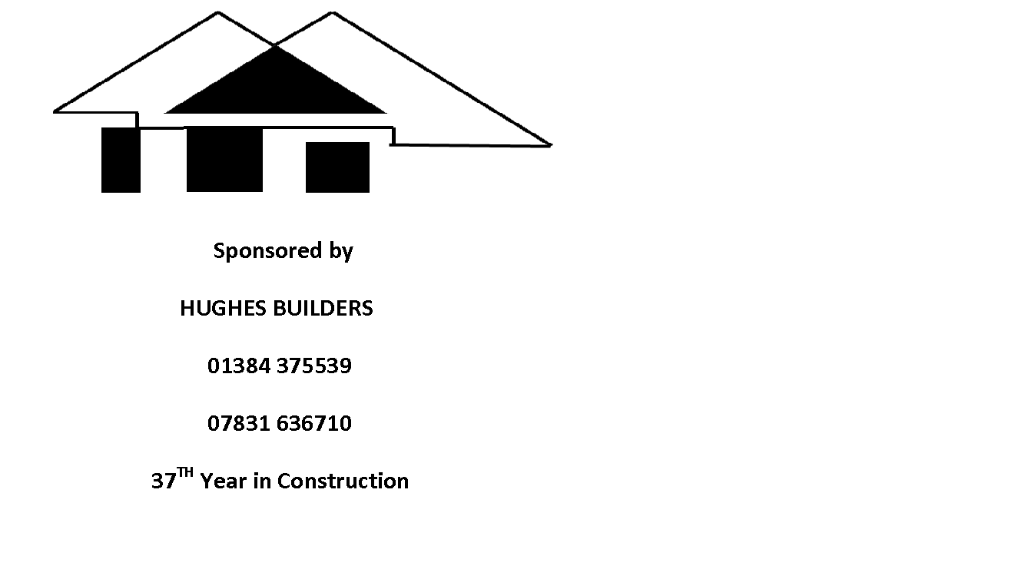
WORCESTERSHIRE COUNTY RACKETBALL CLOSED at STOURBRIDGE
- Earn National Ranking Points
- Age Category Competition
- Trophies for Category Winners
- Early Notification of Draw
- £10 entry/£15 two events

SATURDAY / SUNDAY 17/18th SEPTEMBER 2016

NAME ____________________________ CLUB _______________________________
MOBILE ___________________________ EMAIL _______________________________
T-SHIRT (S,M,L,XL,XXL) _______________ EVENT _______________________________

Tournament to be held at Stourbridge Lawn Tennis and Squash Club, Sugar Loaf Lane, Stourbridge, DY7 6PS.
Payments made by cheque payable to ‘Worcestershire Squash and Racketball Association’ and forwarded to Matt Pugh c/o 17 Blacksmiths Lane, Hockley Heath, Solihull, West Midlands, B946QP. Strict closing date for entry is Monday 12th September 2016. Draw will be forwarded anytime from that date.
Competition offered at Mens Open, Ladies Open, over 40, over 50, over 60 and a Plate competition thus offering all competitors at least two matches.
Entry is restricted to those who are born in or live within the borders of the County of Worcestershire (1973 borders) or are members of a Worcestershire affiliated Club.
All enquiries please to tournament organiser Matt Pugh at m06pugh@gmail.com
(There is a minimum entry figure for each category so competitors may be bumped into higher age categories if there are not enough in their desired tournament).

