BARNT GREEN JUNIOR SUMMER COACHING
With Ian Sherwin
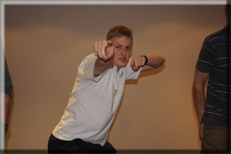

23rd July – 27th August (Every Wednesday excluding Wednesday 20th August)
10am – 3pm
At Barnt Green Sports Club
Sessions include
Fitness Work Racquet Skills Match Practice
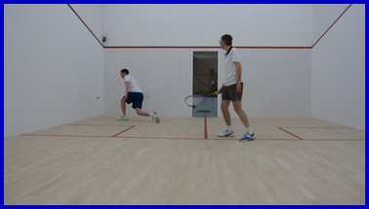Cost £15 per day or £75 for 6 weeks
£7.50 per half day

For more information contact Ian Sherwin on 07824831128 or via email at sherwinian@hotmail.co.uk
BARNT GREEN MINI JUNIOR SUMMER COACHING
With Ian Sherwin

21st July – 29th August
(Every Monday and Friday, excluding Monday 18th & Friday 22nd August)
10am – 12pm
At Barnt Green Sports Club
Sessions include
Fitness Work Racquet Skills Match Practice
Cost £7.50 per session or £40 for 6 weeks
For more information contact Ian Sherwin on 07824831128 or via email at sherwinian@hotmail.co.uk

