@ Barnt Green Sports Club, Margesson Drive, B’ham B45 8LR.

Monday 18th – Friday 22nd August

**With**

**Chris Tasker-Grindley**

**10am – 3pm**

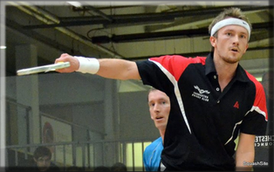

These camps involve **fitness work, racket skills** and **match practice** which will **benefit YOUR games!**

It is a great opportunity for you guys to **TRAIN LIKE A PRO!**

(Please bring packed lunches)

**For just £15 per day!**

For more information or to book a place please contact Chris on 07786716800 or Bett on 07973 273523 or e-mail Bett@bettsquash.co.uk

