WORCESTERSHIRE JUNIOR COUNTY CLOSED
SQUASH CHAMPIONSHIPS 2016
Sponsored by Worcestershire Squash Rackets Association
Date: Saturday 24th & Sunday 25th September 2016
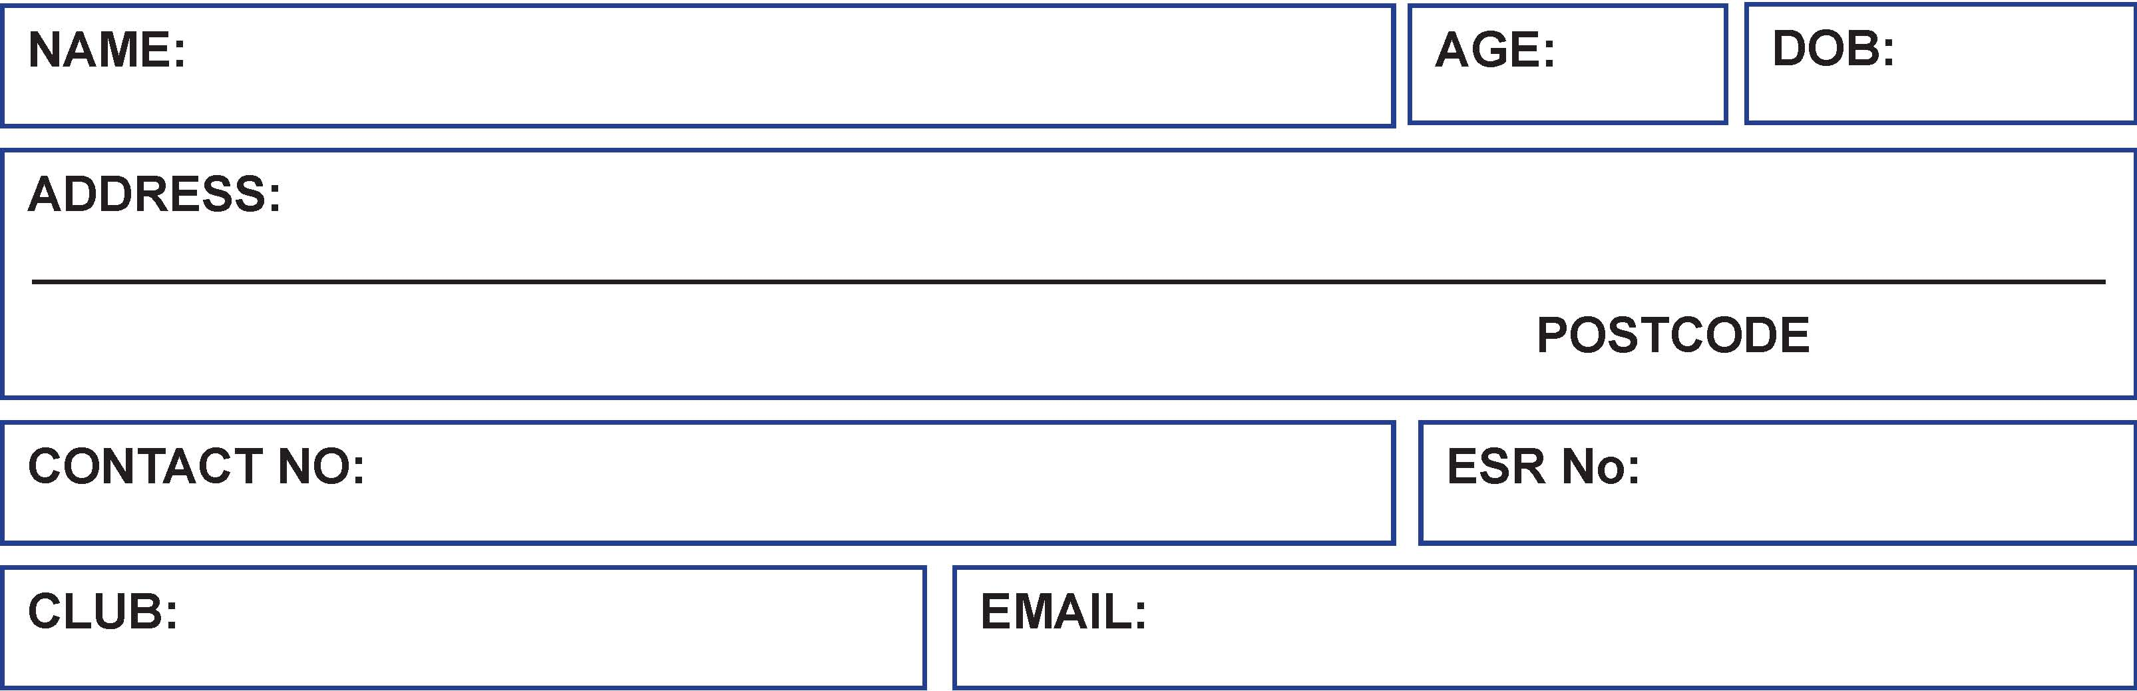
PLEASE INDICATE EVENT

Venue:
Stourbridge Lawn Tennis & Squash Club, Sugar Loaf Lane, Iverley, Stourbridge, West Midlands DY7 6PS

Tournament Director – John Parkes
CLOSING DATE FOR ENTRIES SATURDAY 10TH SEPTEMBER 2016
BOYS | GIRLS |  | AGE
 |  |  | U19
 |  |  | U17
 |  |  | U15
 |  |  | U13
 |  |  | U11
 |  |  | U9
T-shirt Size required (Please Circle) Child Size  Adult size |  |  |  | Age 7-8, 9-11, 12-13  XS, S, M, L, XL
I agree to abide by the tournament rules and conditions |  |  |  |  |  | Signed:
Please indicate any medical issues |  |  |  |  |  | Details:
Parental Consent-
I agree to my child taking part

I agree for my child’s photo to be taken at the event

Please send your completed form with payment £15.00 - Cheques to be made payable to WJS&RA to: Bett Dryhurst, 53 Dawson Road, Bromsgrove, B61 7JF Email - bett@bettsquash.co.uk. Tel 07973 273523.

